Cybersecurity Analyst Internship
Task Report

[samfelix15@gmail.com]
Task No: [ 23 - Security Automation ]

Copyright © 2024 EncryptEdge Labs. All rights reserved
Credit: Offensive Security

Table of Contents
1.0 EncryptEdge Labs Internship Task Report 2
1.1 Introduction 2
1.2 Objective 4
1.3 Requirements 5
2.0 High-Level Summary 10
2.1 Recommendations 11
2.2 Risk exposure over time 11
3.0 Report - Methodologies 12
3.1 Information Gathering 13
4.0 Additionals Item 14
4.1 Screenshots X

- EncryptEdge Labs Internship Task Report

1.1 Introduction
Security automation has become a critical component of modern cybersecurity strategies. The concept of security automation has evolved over the years, driven by the increasing complexity and sophistication of cyber threats. In the early days of cybersecurity, security professionals relied on manual processes to detect and respond to security incidents. However, as the volume and complexity of threats grew, it became clear that manual processes were no longer sufficient.

Security automation has a rich history that dates back to the early 2000s when organizations began using simple scripts to automate repetitive security tasks like virus scanning and patch management. However, these early solutions were fragmented and lacked integration with other security systems.
Early Developments:
2003: The Security Content Automation Protocol (SCAP) was introduced to automate vulnerability management and compliance scanning.
2007: Security Information and Event Management (SIEM) systems emerged, enabling organizations to collect, monitor, and analyze security-related data.
Advancements in Security Automation:
2010s: Machine learning and artificial intelligence started playing a significant role in security automation, enabling automated threat detection and incident response.
2012: Security Orchestration, Automation, and Response (SOAR) solutions were introduced to streamline security operations.
2014: The first machine learning-powered security analytics platforms were launched.
2015: According to the SANS Institute, 61% of organizations reported using security automation tools, up from 45% in 2013.
Security automation refers to the use of technology to automate security tasks, such as threat detection, incident response, and vulnerability management. By automating security tasks, organizations can improve their security posture, reduce the risk of human error, and free up security professionals to focus on more strategic tasks. Let us delve more into all what security automation is all about.

1.2 Objective
The objectives of this report are to:
1. Provide an Overview of Security Automation: This report aims to provide a comprehensive overview of security automation, including its benefits, challenges, and best practices.
2. Identify Key Use Cases: This report will identify key use cases for security automation, including threat detection, incident response, and vulnerability management.
3. Evaluate Security Automation Tools: This report will evaluate various security automation tools and languages, including their advantages and disadvantages.
4. Recommend Best Practices: This report will recommend best practices for implementing security automation, including tips for getting started and avoiding common pitfalls.

Based on this task, my fundamental objectives is to
- Understand the importance of security automation in cybersecurity.
- Learn basic scripting to automate repetitive security tasks.
- Gain hands-on experience creating and executing automation scripts.

Security automation is a critical component of modern cybersecurity strategies, and its importance cannot be overstated. By automating security tasks, organizations can improve their security posture, reduce the risk of human error, and free up security professionals to focus on more strategic tasks.

1.3 Requirements
The requirements for security automation include:
1. Security Orchestration: Security orchestration refers to the ability to integrate multiple security tools and systems, enabling them to work together seamlessly.
2. Automation Tools: Security automation tools, such as security information and event management (SIEM) systems, threat intelligence platforms (TIPs), and security automation frameworks, are essential for automating security tasks.
3. Data Analytics: Data analytics is critical for security automation, as it enables organizations to analyze large volumes of security data and identify patterns and anomalies.
4. Machine Learning: Machine learning is a key technology for security automation, as it enables organizations to automate threat detection and incident response.
But with reference to this task, I am required to,
Submit a report summarizing the importance of security automation and key use cases.
Include a section in your report explaining the language choice, with examples of how it can be used in security automation.
Document the setup process in your report, including configurations made to create an effective test environment.
Include code snippets, explanations of each script’s functionality, and testing results. Describe any challenges and how they were resolved.
Security automation requires a comprehensive approach, including security orchestration, automation tools, data analytics, and machine learning. By leveraging these technologies, organizations can improve their security posture and reduce the risk of cyber threats.
.
Importance of Security Automation
Security automation is crucial for several reasons which includes

Enhanced Efficiency: Automation reduces the time and effort required to detect and respond to security incidents, allowing security teams to focus on higher-level tasks.
Improved Accuracy: Automated systems can analyze large volumes of data, identify patterns, and detect threats more accurately than manual processes.
Reduced Costs: Security automation optimizes security resources and operational expenses by eliminating repetitive security tasks and reducing the need for specialized staff.
Simplified Compliance: Security automation helps organizations manage compliance with regulations such as GDPR, PCI DSS, HIPAA, and NIST by automating audit processes and generating reports.
Faster Threat Detection and Response: Automated systems can process data and uncover patterns that are difficult for humans to recognize.
Reduced Likelihood of Human Error: Automation eliminates manual processes and reduces alerts, minimizing the risk of human error.
Increased Operational Efficiency: Security automation streamlines workflows, enabling security teams to focus on strategic initiatives.
Improved Cybersecurity Resilience: Automated solutions enhance threat detection, certificate management, and firewall security, reducing the risk of cyber threats.

Key Use Cases for Security Automation
Some key use cases for security automation include
Vulnerability Management : Automating vulnerability scanning and prioritization enables organizations to identify and remediate vulnerabilities more efficiently.
Threat Detection and Response: Automated systems can detect threats in real-time, enabling security teams to respond quickly and effectively.
Incident Response: Automation can help contain and mitigate security threats, reducing the impact of a breach.
Credential Monitoring: Automating credential monitoring enables organizations to detect compromised credentials and respond promptly to potential incidents.
Enriching Indicators of Compromise (IoCs): Automation can enrich IoCs, providing security teams with critical information to make informed decisions.

Best Practices for Implementing Security Automation
To get the most out of security automation, organizations should,
Define Objectives and Scope: Clearly define the objectives and scope of security automation initiatives.
Conduct a Comprehensive Assessment: Identify high-impact areas and plan the automation rollout.
Ensure Compatibility with Existing Infrastructure: Integrate security automation tools with existing security systems and infrastructure.
By implementing security automation, organizations can improve their security posture, reduce costs, and enhance their incident response capabilities. As security automation continues to evolve, it will play an increasingly important role in supporting cybersecurity efforts and protecting against emerging threats.

Tools and Languages Used for Security Automation
There are a variety of tools and languages used for security automation, including:
1. Python: Python is a popular language used for security automation, due to its flexibility and extensive libraries.
2. Ansible: Ansible is an open-source automation tool that can be used for security automation, including automating security tasks and processes.
3. Splunk: Splunk is a security information and event management (SIEM) system that can be used for security automation, including monitoring and analyzing security data.
4. Security Orchestration, Automation, and Response (SOAR): SOAR solutions are designed to automate and streamline security incident response processes.

Selected Tool: Python
Python is a popular language used for security automation, due to its flexibility and extensive libraries. Python can be used for a wide range of security automation tasks, including:
Threat detection: Python can be used to detect threats in real-time, using machine learning and anomaly detection techniques.
Incident response: Python can be used to automate incident response processes, including sending notifications and escalating incidents.
Vulnerability management: Python can be used to automate vulnerability management processes, including identifying and prioritizing vulnerabilities, and applying patches and updates.
Advantages of Python for Security Automation
The advantages of using Python for security automation include:
Flexibility: Python is a flexible language that can be used for a wide range of security automation tasks.
Extensive libraries: Python has extensive libraries and frameworks that make it easy to automate security tasks.
Large community: Python has a large and active community, which means there are many resources available for learning and troubleshooting.
Future Impact
The future impact of security automation is likely to be significant, as organizations increasingly adopt automation technologies to improve their security posture. Security automation will enable organizations to:
Improve incident response: Security automation will enable organizations to respond more quickly and effectively to security incidents.
Reduce cost: Security automation will enable organizations to reduce the costs associated with manual security tasks.
Enhance security posture: Security automation will enable organizations to improve their security posture, by automating security tasks and processes.
Conclusion
Security automation is a critical component of modern cybersecurity strategies, enabling organizations to automate security tasks, improve their security posture, and reduce the risk of human error. By leveraging security automation tools and languages, such as Python, organizations can improve their incident response, reduce costs, and enhance their security posture. As security automation continues to evolve, it will play an increasingly important role in supporting cybersecurity efforts and protecting against emerging threats. ‎
2.0 High-Level Summary

Security automation is a vital component of modern cybersecurity strategies, enabling organizations to enhance their security posture, improve efficiency, and reduce the risk of human error. By automating security tasks, organizations can streamline their security operations, freeing up security professionals to focus on more strategic initiatives.
Security it is a critical component of modern cybersecurity strategies, making it quiet stress free for organizations to automate security tasks, improve their security posture, and reduce the risk of human error. Key use cases for security automation include threat detection, incident response, and vulnerability management.
To add to this ,security automation tools and languages, such as Python, Ansible, and Splunk, offer a range of benefits, including improved efficiency, enhanced accuracy, and reduced costs. However, implementing security automation requires careful planning, including evaluating security requirements, selecting the right tools and technologies, and developing a comprehensive automation strategy.
Last but not least, automation is a critical component of modern cybersecurity strategies, enabling organizations to automate security tasks, improve their security posture, and reduce the risk of human error. By leveraging security automation tools and languages, such as Python, organizations can improve their incident response, reduce costs, and enhance their security posture. As security automation continues to evolve, it will play an increasingly important role in supporting cybersecurity efforts and protecting against emerging threats. ‎

2.1 Recommendations
Based on the importance of security automation, it is recommended that organizations:
1. Implement Security Automation : Organizations should implement security automation to improve their security posture, reduce the risk of human error, and free up security professionals to focus on more strategic tasks.
2. Select the Right Tools: Organizations should select security automation tools and languages that meet their security requirements and integrate with existing security systems.
3. Develop an Automation Strategy: Organizations should develop a comprehensive automation strategy, including identifying key use cases, defining automation workflows, and establishing metrics for measuring success.
By implementing security automation, organizations can improve their security posture, reduce costs, and enhance their incident response capabilities.

2.2 Risk Exposure over Time
The risk exposure over time for organizations that do not implement security automation can be significant. Without automation, security teams may struggle to keep up with the volume and complexity of security threats, leading to:
1. Increased Risk of Security Breaches: Without automation, organizations may be more vulnerable to security breaches, as security teams may not be able to detect and respond to threats in a timely manner.
2. Increased Costs: Without automation, organizations may incur higher costs, as security teams may need to spend more time and resources on manual security tasks.
3. Reduced Efficiency: Without automation, security teams may be less efficient, as they may need to spend more time on manual security tasks, rather than focusing on more strategic initiatives.

3.0 Methodologies
The methodology for implementing security automation includes:
1. Evaluating Security Requirements: Organizations should evaluate their security requirements, including identifying key security tasks and processes that can be automated.
2. Selecting Tools and Technologies: Organizations should select security automation tools and technologies that meet their security requirements and integrate with existing security systems.
3. Developing an Automation Strategy: Organizations should develop a comprehensive automation strategy, including identifying key use cases, defining automation workflows, and establishing metrics for measuring success.
By following a structured methodology, organizations can ensure that their security automation initiatives are successful and effective.

3.1 Information Gathering
Information gathering is a critical component of security automation, enabling organizations to collect and analyze large volumes of security data. Key sources of security data include:
1. Security Logs: Security logs provide a wealth of information about security events, including login attempts, network traffic, and system activity.
2. Threat Intelligence: Threat intelligence provides information about known threats, including malware, phishing attacks, and vulnerability exploits.
3. Network Traffic: Network traffic provides information about network activity, including incoming and outgoing traffic.
By gathering and analyzing security data, organizations can identify patterns and anomalies, detect threats, and respond to incidents.
With reference to this report, information was gathered by continuous studies and knowledge acquisition, articles, journals, Github Repos, educative useful Urls provided to me by EncryptEdgeLabs and finally constant selfless services from my mentor.

GitHub Repos:
- Powershell Scripts for Blue Team

Articles:
- Cybersecurity in the Automated Era
- The Role of Automation in Cybersecurity
- Automate Cybersecurity Tasks with Python
- Important PowerShell Commands for Cybersecurity Analysts

Final Thoughts
In conclusion, security automation is a powerful tool that can help organizations improve their security posture, reduce costs, and enhance their incident response capabilities. By following best practices and leveraging the right tools and technologies, organizations can get the most out of security automation and stay ahead of emerging threats

4.0 Additional Items
4.1 Screenshots
This section will include screenshots of mandatory completed lab tasks assigned to me. The lab will include screenshots of
Python Basics and Bash Scrpting.
However these screenshots serves as a guide in understanding the fundamentals of Bash scripting and understanding the basics of python for security automation purposes. For more info, refer to page14. Thanks.

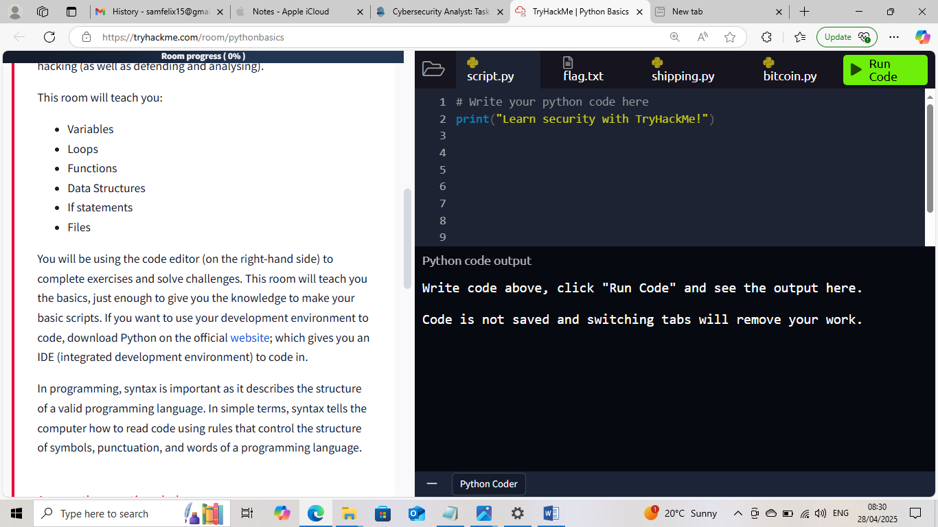

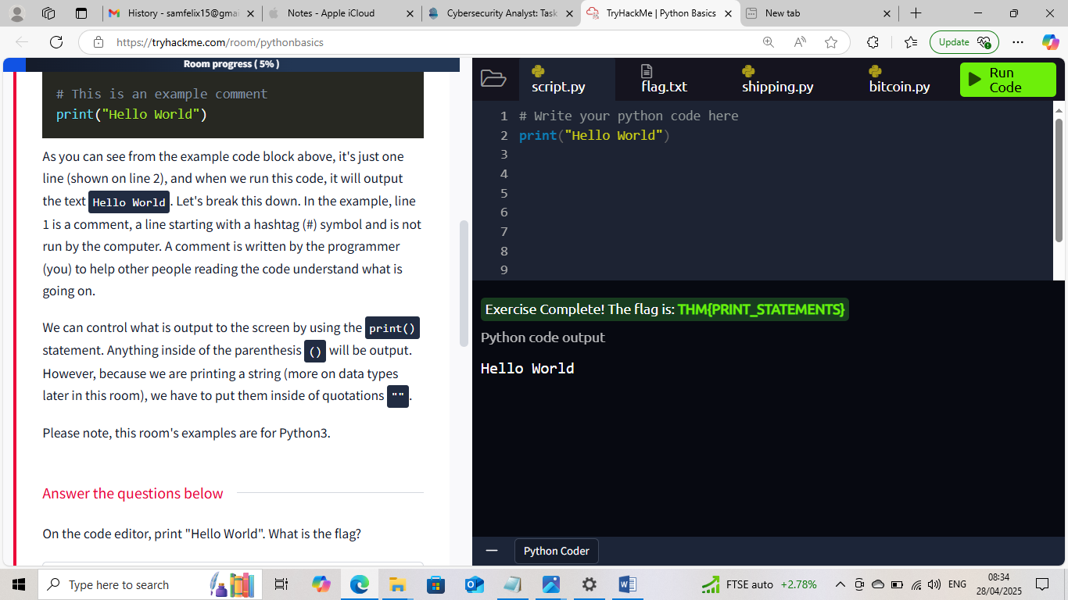
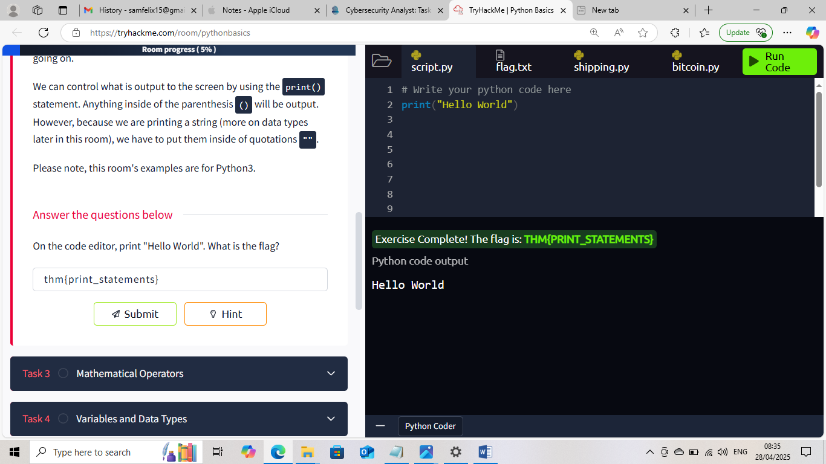

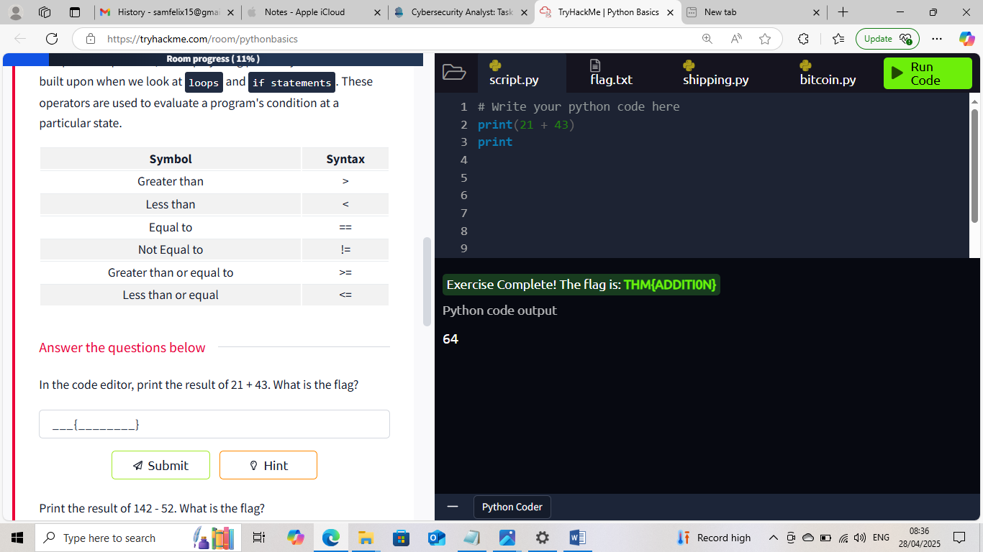

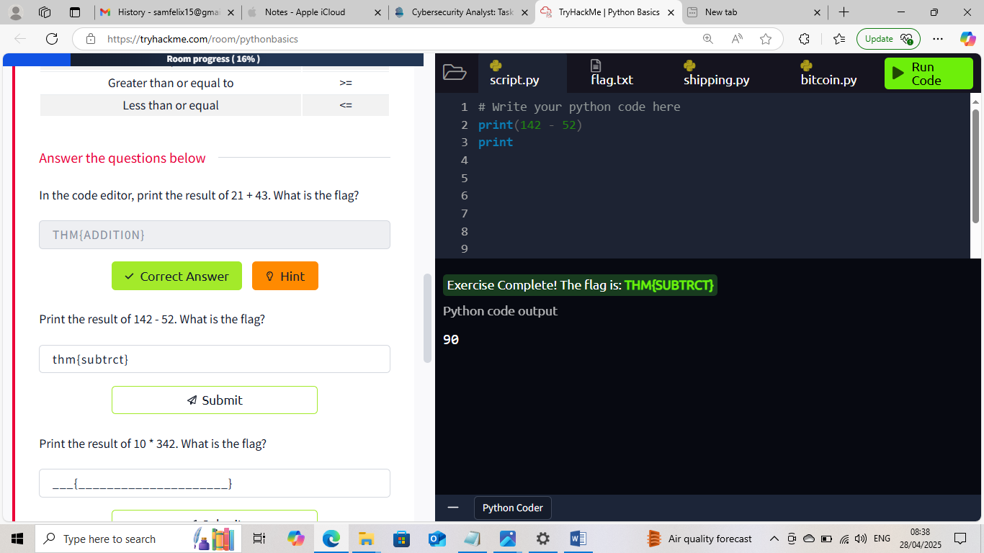

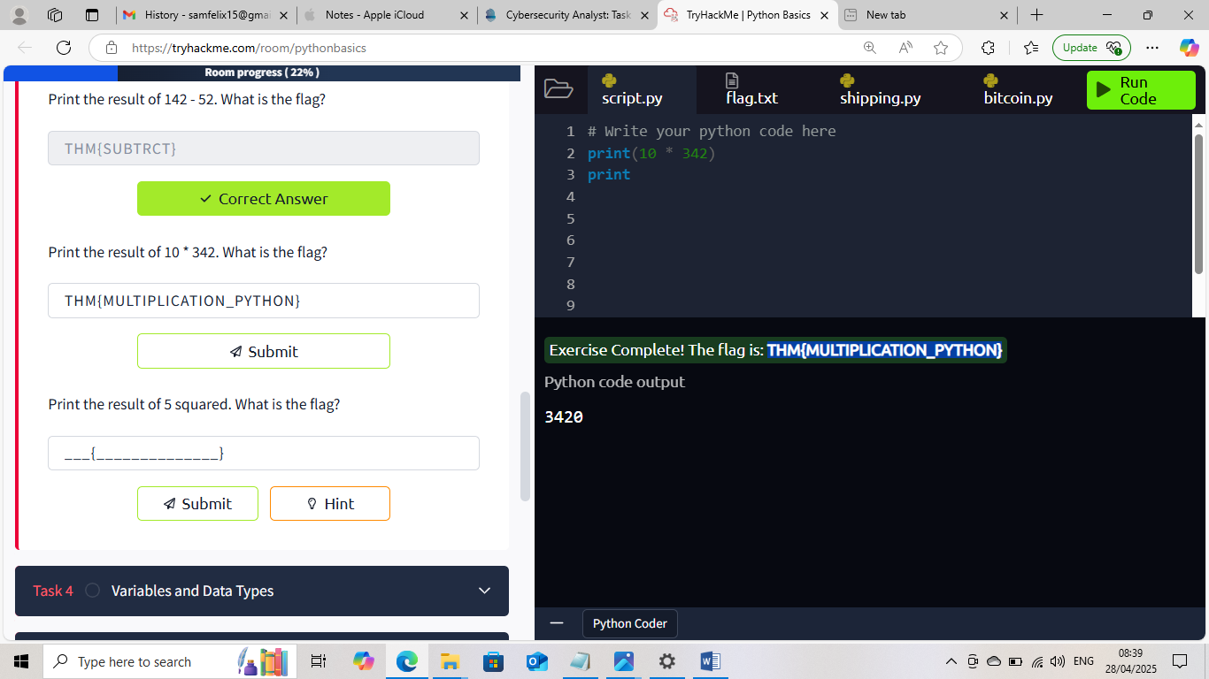

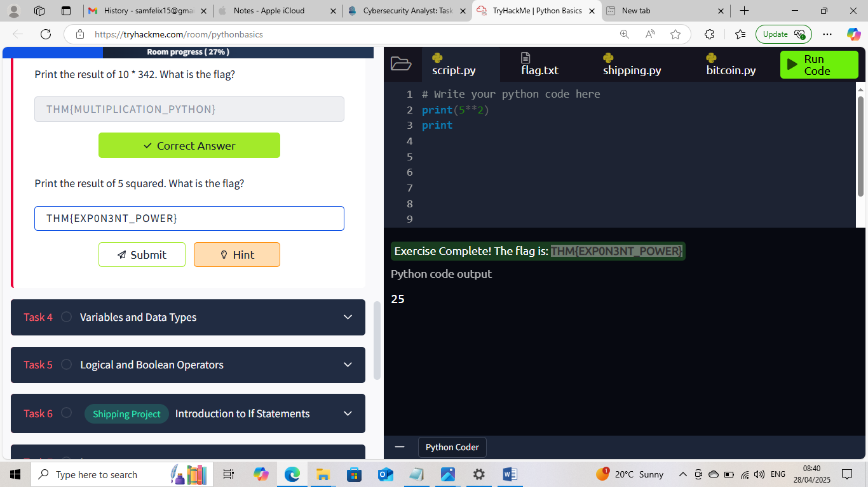


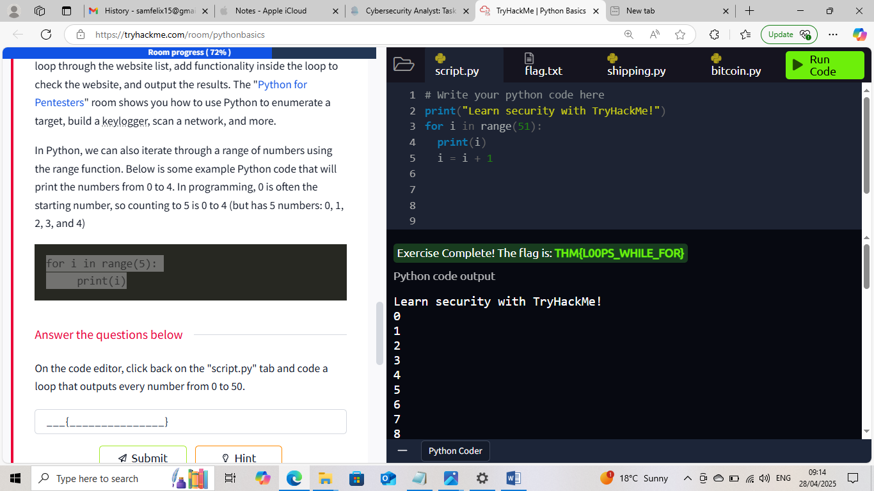

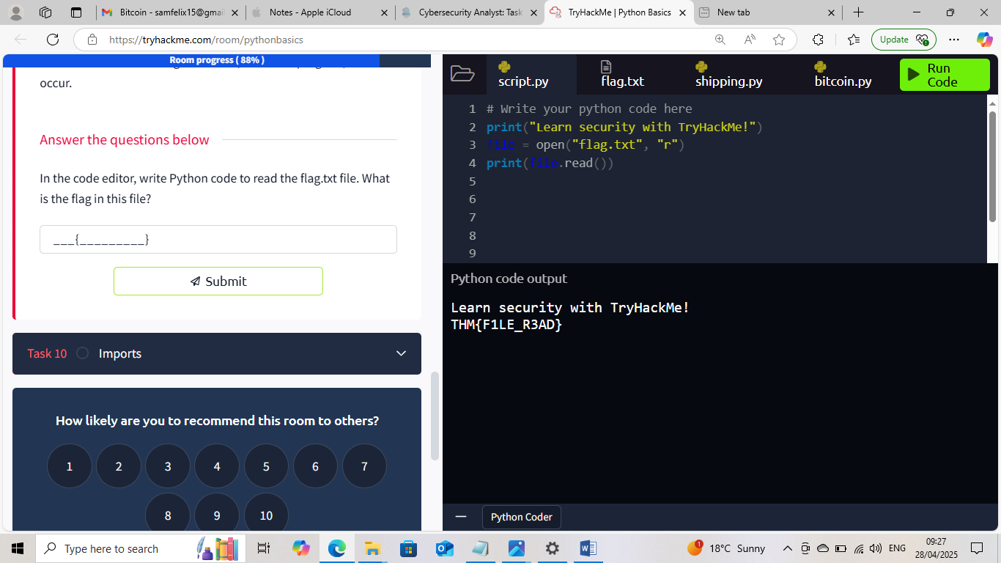

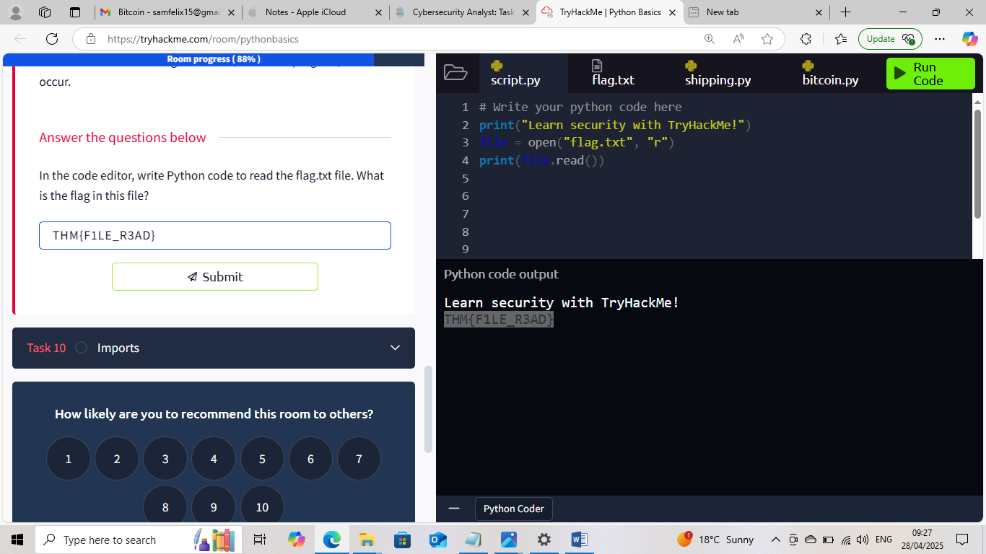

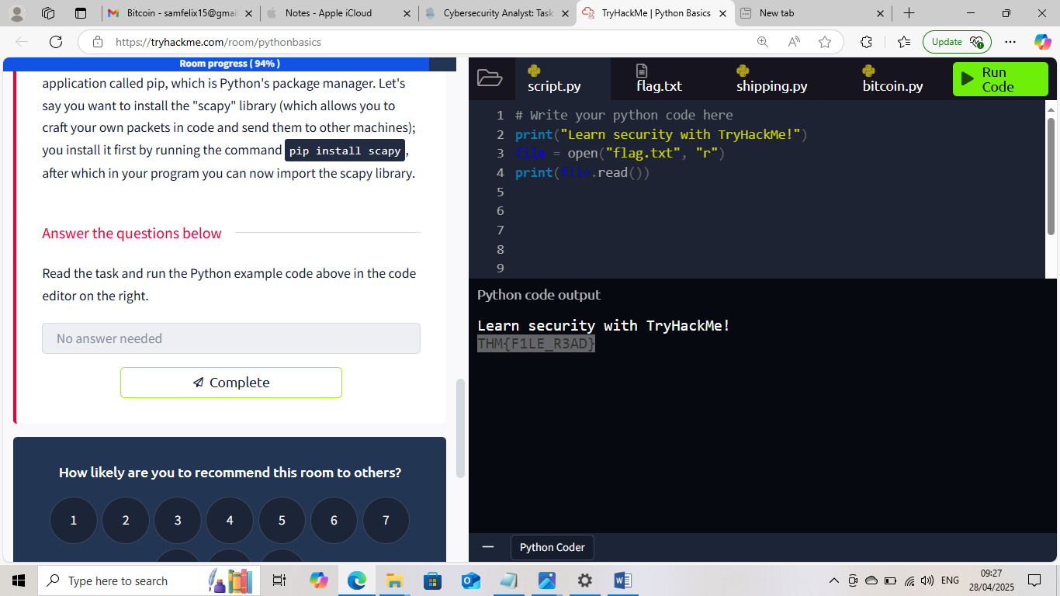



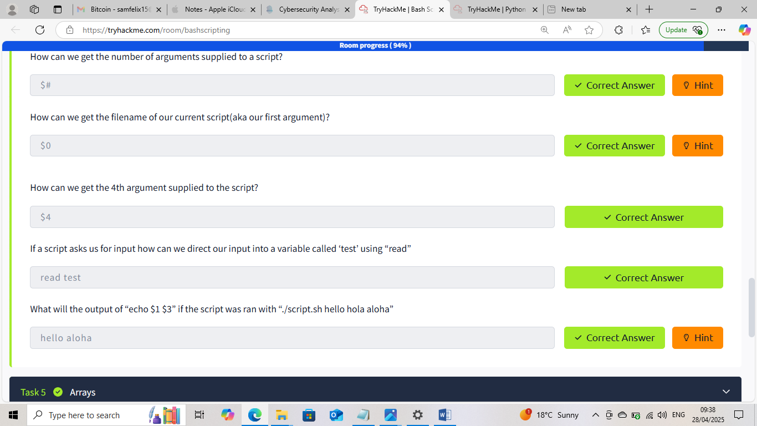







This Internship Task report was developed on [April, 28, 2025]

By:
[ samfelix15@gmail.com ]

